Software Development Testing Plan

Rapid Application Development

17/11/2019

ACME Entertainment Pty Ltd

SOUTH METROPOLITAN TAFE

Table of Contents

0

Overview 2

Functional and Regression Testing 2

GUI and Usability Testing 2

Accessibility Testing 2

Compatibility Testing 2

Performance Testing 2

Installation / Configuration Testing 2

System Integration Testing (SIT) 2

Security Testing 2

Internationalization / Localization Testing 2

User Acceptance Testing (UAT) 3

Testing Table 3

Screenshot 4

Bibliography 28

Glossary of Term 29

# Overview

This Software Development Testing Plan (SDTP) is used to test out the features and functionality of the Responsive Design website according to the CITE Quality Assurance as below:

## Functional and Regression Testing

**Functional testing** is performed to ensure all functionalities of an application is working as expected.

**Regression testing** is performed once a build is released to check the existing functionality. (360 Logica, n.d.)

## GUI and Usability Testing

**Usability Testing** is focused on the end user and checks the impressions of the application usage.

**GUI Testing** is performed on various platforms in order to check the look and feel of the application.

(Professional QA, n.d.)

Accessibility Testing

Performed to ensure that the application being tested is usable by people with disabilities like hearing, color blindness, old age and other disadvantaged groups.

(Guru 99, n.d.)

## Compatibility Testing

Check whether the software is capable of running on different hardware, operating systems, applications, network environments or Mobile devices.

(Guru 99, n.d.)

## Performance Testing

**Performance testing** is the process of determining the speed, responsiveness and stability of a computer, network, software program or device under a workload.

(Guru 99, n.d.)

## Installation / Configuration Testing

Test the performance of a software product on a machine with different hardware or software configurations namely, operating system, browser, supported drivers.

(Guru 99, n.d.)

## System Integration Testing (SIT)

Carried out in an integrated hardware and software environment to verify the behavior of the complete system. It is testing conducted on a complete, integrated system to evaluate the system's compliance with its specified requirement.

(Wikipedia, n.d.)

## Security Testing

Ensures software systems and applications are free from any vulnerabilities, threats, risks that may cause a big loss.

(Guru 99, n.d.)

Internationalization / Localization Testing

**Internationalization** is making the application such that it supports multiple languages/locales.

**Localization** is making an application support a particular locale and language.

(Software Testing Help, n.d.)

## User Acceptance Testing (UAT)

Last phase of software testing, users test the software to make sure it can handle required tasks in real-world scenarios, according to specifications.

(Techopedia, n.d.)

# Testing Table

|  |  |  |  |  |
| --- | --- | --- | --- | --- |
| Case No | Test types | Description | Status | Evidence |
| 1 | Functional and Regression Testing | All the functions are works perfectly | Tested | Figure 1.1.1 – Figure 3.3.2 |
| 2 | GUI and Usability Testing | The website has navigation bar, text boxes and buttons to go thru | Tested | Figure 1.2.1  Figure 2  Figure 3.1.1 – Figure 3.2.3 |
| 3 | Accessibility Testing | Doesn’t have any functions for disadvantages group such as deaf/blind, disabilities people. | N/A | N/A |
| 4 | Compatibility Testing | Is compatible for different platforms such as laptop, mobiles, and computers, tablets. | Tested | Figure 1.3  Figure 2.1 |
| 5 | Performance Testing | No workload is applicable in this testing | N/A | N/A |
| 6 | Installation / Configuration Testing | Work well on different operating system, browsers | Tested | Figure 1.1  Figure 2.1 |
| 7 | System Integration Testing (SIT) | Data exchanges (data import/export) happens between the system components (MySQL & HTML/PHP) and then the behavior of each data field within the individual layer is examined. | Tested | Figure 1.4 Figure 2.3.2/3  Figure 3.1.1- Figure 3.2.3 |
| 8 | Security Testing | Security features likes authorization credentials has implemented in admin login page | Tested | Figure 2.2.1  Figure 3.2.1 – Figure 3.3.2 |
| 9 | Internationalization / Localization Testing | Its only available in English languages | N/A | N/A |
| 10 | User Acceptance Testing (UAT) | End users testing with the basic functions of searching movies, show all movies, and top 10 movies, admin login, memberships subscribe/unsubscribe | Tested | Figure 1  Figure 2  Figure 3 |

# Screenshot

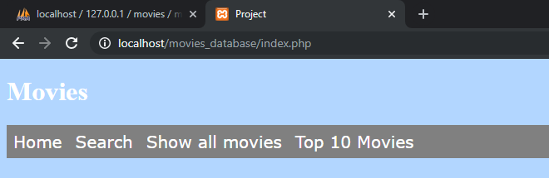

Figure 1.1.1 Google Chrome browser

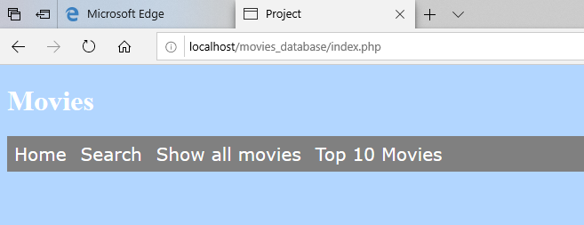

Figure 1.1.2 Microsoft Edge browser

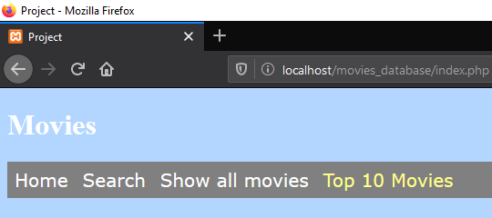

Figure 1.1.3 Mozilla Firefox browser

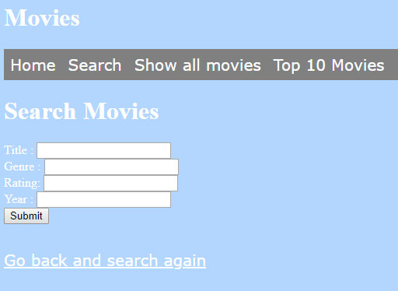

Figure 1.2.1 – GUI – Navigation bar, text boxes, buttons, and hyperlinks

  
Figure 1.3.1 – iOS Mobile landscape mode

  
Figure 1.3.2 – iOS Mobile portrait mode

  
Figure 1.3.3 – iOS tablet landscape mode

  
Figure 1.3.4 – iOS tablet portrait mode

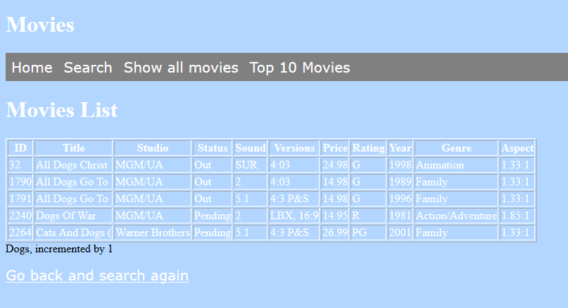

Figure 1.4.1 – Search function works well with database

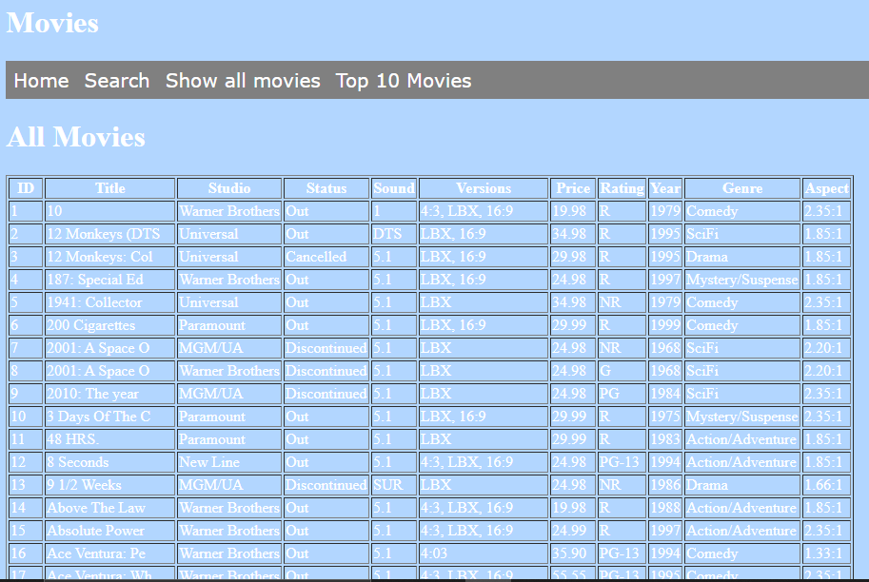

Figure 1.4.2 – All movies pages

Figure 2.1.1 – Scalability fixed on iOS table landscape mode

Figure 2.1.2 – Scalability fixed on iOS table portrait mode

Figure 2.1.3 – Scalability fixed on iOS mobile landscape mode

Figure 2.1.4 – Scalability fixed on iOS mobile portrait mode

Figure 2.1.5 – Scalability fixed on browser IE landscape mode  
Figure 2.1.6 – Scalability fixed on browser IE portrait mode  
Figure 2.1.7 – Scalability fixed on browser firefox landscape mode  
Figure 2.1.8 – Scalability fixed on browser IE portrait mode  
Figure 2.1.9 – Scalability fixed on browser google chrome landscape mode  
Figure 2.1.10 – Scalability fixed on browser google chrome portrait mode

Figure 2.2.1 – Admin login features with username and password – admin/admin  
Figure 2.2.2 – Show subscribed member and member removal once admin logged in  
Figure 2.2.3 – Displayed all members  
Figure 2.3.1 – Memberships subscription page

Figure 2.3.2 – Member joins subcription added into database succesfully   
Figure 2.3.3 – Another member joins subcription added into database succesfullyA screenshot of a cell phone

Description automatically generated  
Figure 2.4.1 – Memberships unsubcribe page  
Figure 2.4.2 – Enter email wanted to unsubcribe and it will prompt a compose mail to the administrator email address in order to unsubscribe on behalf.

Figure 2.4.3 – Administrator email address received unsubscribe email from member.

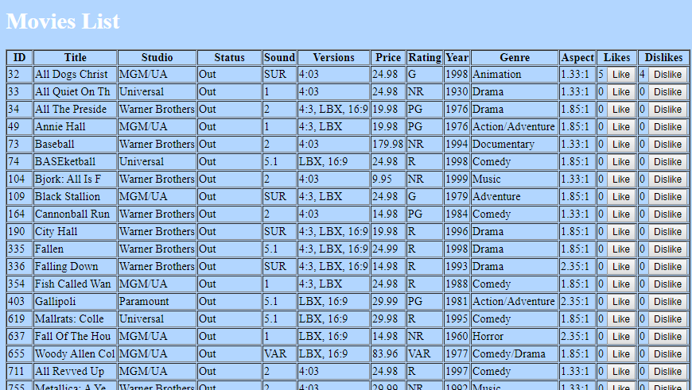

Figure 3.1.1 – Searched movies with rating feature added (like and dislikes)

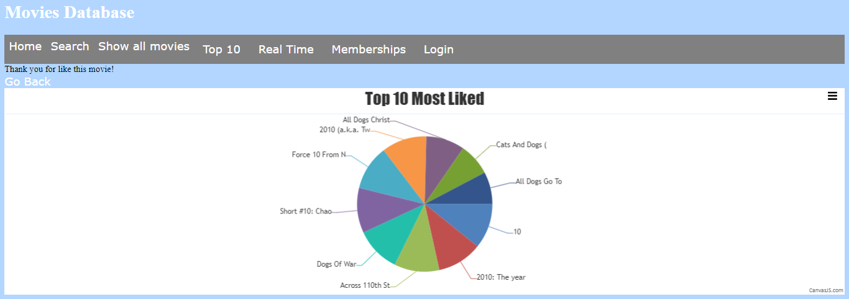

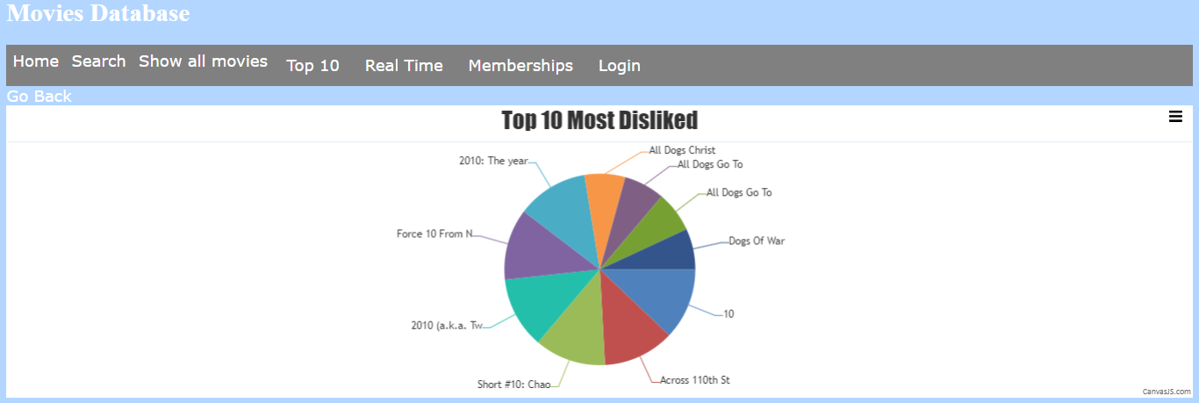

Figures 3.1.2 – Dynamic graphs of Top 10 liked & Disliked movies

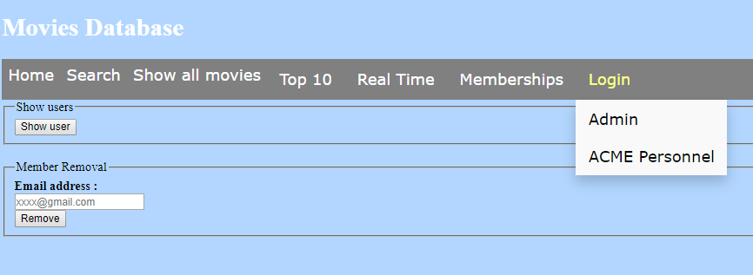

Figure 3.2.1 – User groups login function Admin and ACME Personnel (Admin view)

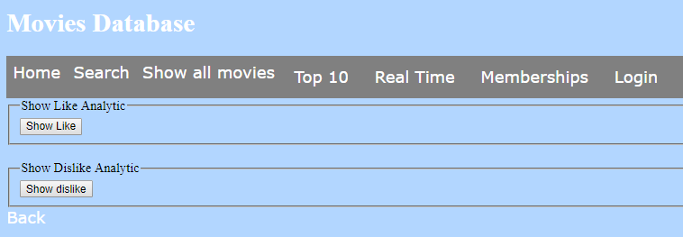

Figure 3.2.2 – User groups login function Admin and ACME Personnel(ACME Personnel view)

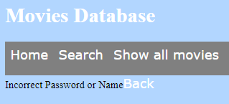

Figure 3.2.3 – Login failed message of the wrong user groups credentials.

Figure 3.3.1 – Admin user groups creation

Figure 3.3.2 – Password strength requirement

# Bibliography

*360 Logica*. (n.d.). Retrieved from https://www.360logica.com/blog/regression-testing-vs-functional-testing/

*CITE Managed Services*. (n.d.). Retrieved from http://www.citems.com.au/?page_id=84

*Guru 99*. (n.d.). Retrieved from https://www.guru99.com/accessibility-testing.html

*Guru 99*. (n.d.). Retrieved from https://www.guru99.com/compatibility-testing.html

*Guru 99*. (n.d.). Retrieved from Performance Testing: https://www.guru99.com/performance-testing.html

*Guru 99*. (n.d.). Retrieved from Configuration Testing: https://www.guru99.com/configuration-testing.html

*Guru 99*. (n.d.). Retrieved from Security Testing: https://www.guru99.com/what-is-security-testing.html

*Professional QA*. (n.d.). Retrieved from http://www.professionalqa.com/gui-testing-vs-usability-testing

*Software Testing Help*. (n.d.). Retrieved from Localization and Internationalization: https://www.softwaretestinghelp.com/localization-and-internationalization-testing/

*Techopedia*. (n.d.). Retrieved from UAT: https://www.techopedia.com/definition/3887/user-acceptance-testing-uat

*Wikipedia*. (n.d.). Retrieved from System Integration Testing: https://en.wikipedia.org/wiki/System_integration_testing

# Glossary of Term

**System Integration Testing (SIT)** – This is a software solution designed to deliver instructional content.

**User Acceptance Testing (UAT)** – This is last phase of the software testing process. During this phase, actual software users test the software to make sure it can handle required tasks in real-world scenarios, according to specifications.

**Graphic User Interface (GUI)** – This is a form of user interface that allows users to interact with electronic devices through graphical icons and audio indicator.

**Structured Query Language (MySQL)** - This is an open-source relational database management system. Its name is a combination of “My”, the name of co-founder Michael Widenius’s daughter, and “SQL”, the abbreviation for Structured Query Language.

**Hypertext Mark-up Language (HTML)** – This is the standard mark-up language for documents designed to be displayed in a web browser.

**Hypertext Pre-processor (PHP)** – This is a general-purpose programming language originally designed for web development.